Instructions to run Multistage on a single PC

Starting and Running a Session
Execute 'server-multistage.bat' in the bin subdirectory
- Select the number of players by clicking on the 'Set Number of Players' button. The number of players must be even.
- Load the parameters file ‘xxxx.txt' which resides in the metadata folder by clicking on the 'Load Parameters File' button and choosing the file.
- Set an output file to a file on the desktop by clicking on the 'Set Output File' button. The output will be saved to this location each time the 'Next Game' button is pressed.
- Click on 'Authenticate Clients' to begin authentication. When all of the clients are connected, click on 'Confirm.' All the clients will now be displayed in the Client Monitor section of the interface.
- Click on 'Start Game' to begin the first game of the first match. The clients will now be partnered and color-coded, organized by group.
- Proceed through all specified rounds and matches, clicking the "Next Round" and "Next Match" buttons to continue to the next round or match when applicable. After the first few rounds you can set it to advance automatically by choosing ' Setup' from Menu Options and clicking on auto advance.
- When the final match is complete, the 'Write Output' button will appear in place of the 'Disconnect Server' button. Press this button to disconnect all the clients and get the final output. Output will be written to the file specified in step 4, including a file with a .pay extension, which specifies payments owed each player.
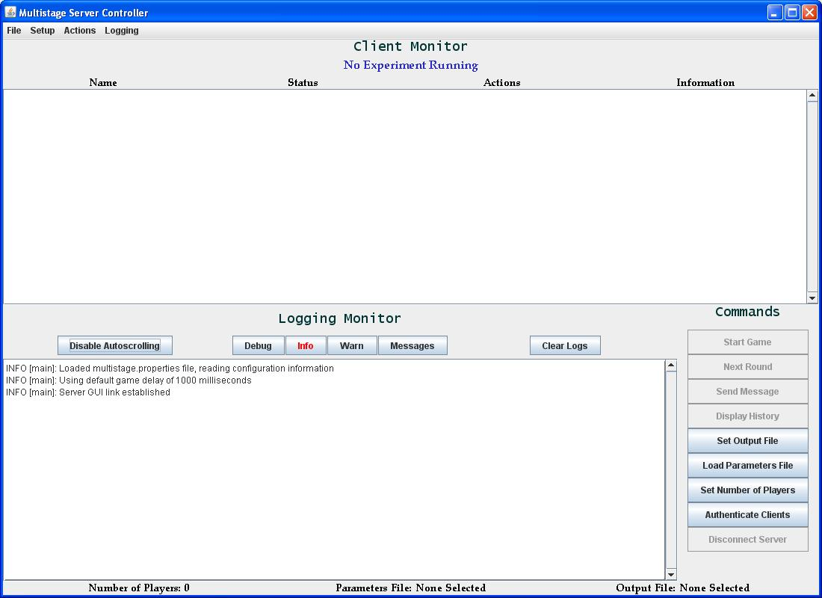
The Client Interface

Connecting To The Server
- Double click the shortcut to ‘client-multistage.bat’ on your desktop
- Enter a subject name, then click the "Submit" button. Make sure this is a name that you can remember -- when you get disconnected you will have to enter the same name as you have typed in before to get reconnected.

What could go wrong?

Clients may accidentally get disconnected and the experimenter will have to reauthenticate them. When they’re disconnected their status indicator will turn red and say ‘Disconnected’ instead of the green ‘Connected.’ At this point, that client’s ‘Reauth’ button will be enabled. To reauthenticate the client:
- Click on the client’s ‘Reauth’ button.
  - Note that reauthentication can only be done one client at a time.
  - The Server will now wait for the client to reconnect.
- On the client side, start up a new client on any computer.
- Open the ‘Options’ menu and select the Reauthenticate box in the client Initialization screen. This is important, otherwise the server will not know that the client is trying to reauthenticate.
- Type in the appropriate host, and type in the clients name EXACTLY as it appears in the Server Reauthentication window (it should be the exact same name they had typed in before).
- The server Reauthentication screen should switch to ‘Connected’. At this point, click on ‘Confirm.’
- The client should now be back in the game as normal.

